**Reference No:** C03…..

**Damage Report Date:** .22/11/12...

**Incidents must be reported immediately.**

Damage found in Container must not to be touched until pictures have been taken to effectively demonstrate to stake holders how damage could have arised?

In Container Container No:

In Warehouse How was it damaged? NOT REPORTED

Product…YM1430 MARIMBA……………….. Qty………1…………

*Insert* Picture:

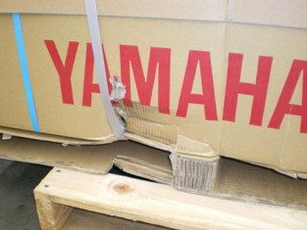

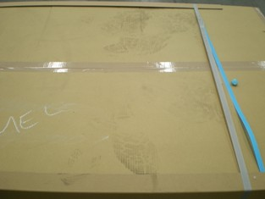

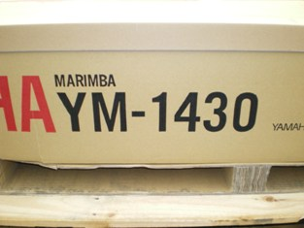

Reported by…Frank Vastag…………………………………………………………………….